
K.S. SCHOOL OF ENGINEERING AND MANAGEMENT, BANGALORE - 560109
DEPARTMENT OF COMPUTER SCIENCE AND ENGINEERING
SESSION: 2024-2025 (EVEN SEMESTER)
FIRST ASSIGNMENT

Degree | : | B.E | Semester | : | IV
Branch | : | CSE | Course Code | : | BCS401
Course Title | : | Analysis & Design of Algorithms | Max Marks | : | 25
Date | : | 11/3/2025 | Last Date for submission | : | 17/3/2025

Q No. | Questions | Marks | K-  Level | CO mapping
1 a | Develop a general plan for analyzing time efficiency of non-recursive algorithms with example. Solve the worst-case analysis for the algorithm to check whether all the elements in a given array are distinct. | 2 | Applying  K3 | CO1
b | Develop a general plan for the analyzing time efficiency of recursive algorithms with an example. Develop the recursive algorithm to find the factorial of a number. Derive its efficiency. | 2 | Applying  K3 | CO1
c | Experiment with asymptotic notations in detail with examples.  Apply three asymptotic notations on the following assertions  - n*(n-1)/2 ii. 6*2^{n}+n² iii. 100n + 5 | 1 | Applying  K3 | CO1
2 a | Demonstrate time and space complexity of the algorithm. | 2 | Applying  K3 | CO1
b | Develop an algorithm for bubble sort and apply the algorithm to sort the following list in ascending order.  60, 50, 25, 10, 35, 25, 75, 30. | 2 | Applying  K3 | CO1
c | Develop the algorithm to find the maximum element in the list of n numbers.  Identify the following  a) Algorithm basic operation  b) Number of times the basic operation executes  c) Derive its efficiency. | 1 | Applying  K3 | CO1
3 a | 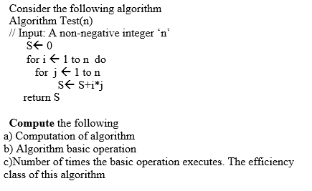 | 2.5 | Applying  K3 | CO1
b | Develop an algorithm to search an element in an array using sequential search. Identify the worst case, best case and average case efficiency of this algorithm. | 2.5 | Applying  K3 | CO1
4 a | Apply insertion sort to sort the list E, X, A, M, P, L, E in  alphabetical order. | 2.5 | Applying  K3 | CO2
b | Develop an algorithm for selection sort and apply the algorithm to sort the following list in ascending order.  60, 50, 25, 10, 35, 25, 75, 30. | 2.5 | Applying  K3 | CO2
5 a | What is topological sorting? Apply DFS for below graph to solve topological sorting.  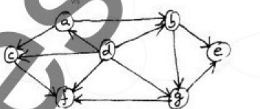 | 2.5 | Applying  K3 | CO2
b | Apply source removal method for below graph to solve topological sorting.  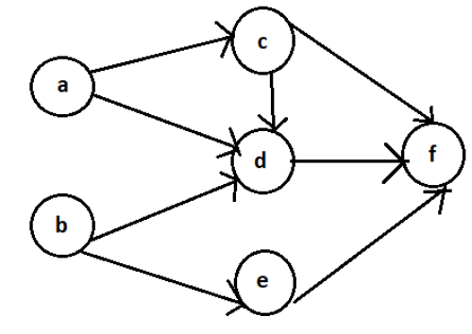 | 2.5 | Applying  K3 | CO2

Course In charge HOD

